**Ideation Phase**

**Hidden Treasures of Mushroom Template**

|  |  |
| --- | --- |
| Date | 04 May 2023 |
| Team ID | NM2023TMID19096 |
| Project Name | Un Covering The Hidden Treasures of Mushroom Kingdom. A classification analysis |
| Maximum Marks | 4 Marks |

**Hidden Treasures of Mushroom Template:**

Mushrooms, its a natural gift for all living things, because it was a highly lifetime potential and very useful to several ways like, Pharma industries, Agriculture and Allied industries with food sector also. We do not know the full bio-ecological surveillance, biology of mushrooms and its uses.

In this book described about importance, biology and how to cultivate mushrooms and preserved it for commercial purposes and adding the knowledge about poisonous mushrooms and how we know that. Finally, in future the gene editing technologies were implemented for desirable for upcoming new ones within next fifty years.

Reference link: https:// https://www.research. Mushrooms_-A_Hidden_Treasure

**Step-1: Team Gathering, Collaboration and Select the Problem Statement**

**Team Gathering:**

A basket of mushrooms and a pair of colorful gloves: at a first glance, the two do not have much in common. “People are often unaware of the incredible resources that can be found in woodlands. It is really amazing to see the beauty of the dyes extracted from fungi” said Andrey Zaytsev . Mushrooms provide important nutrients, including selenium, potassium, ribolavin, niacin, vitamin D, proteins. As a result of these properties, some mushroom extracts are used to promote human health and are found as dietary supplements

**Collaboration :**

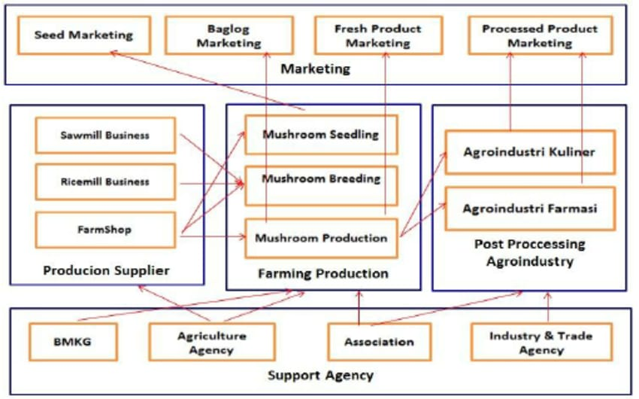

**REFERENCE LINK:** <https://www.researchgate.net/figure/Collaboration-and-information-sharing-between-Mushroom-Agribusness-stakeholder_fig1_287240710>

**Step-2: Mushroom Idea, Listing and Grouping**

**Mushroom Ideas**

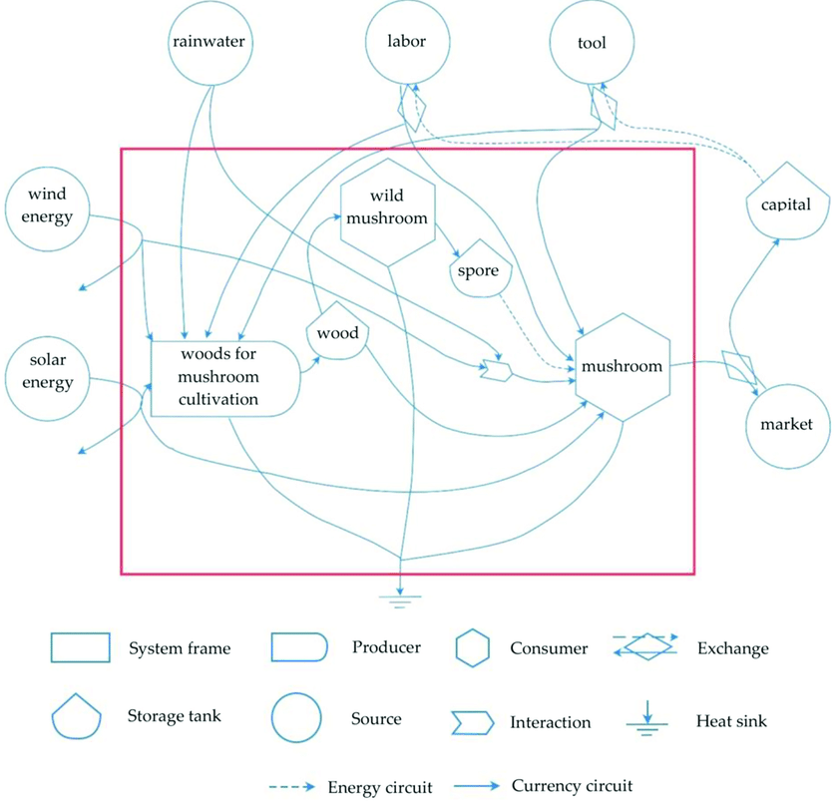

**Mushroom Listing and Grouping**

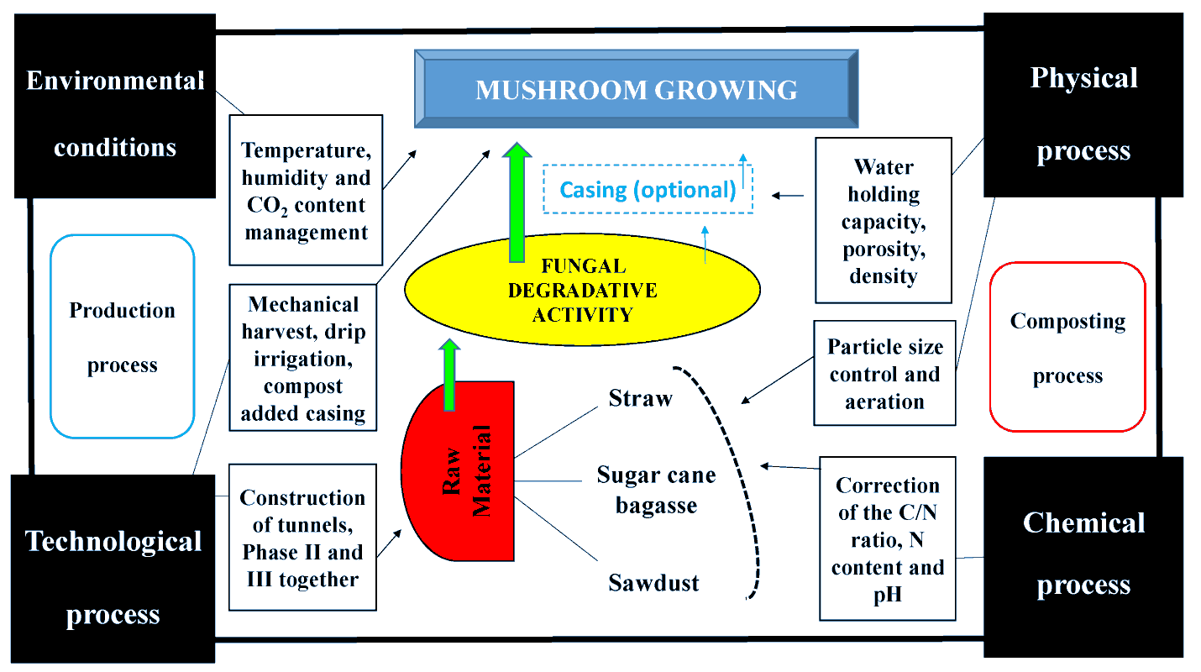

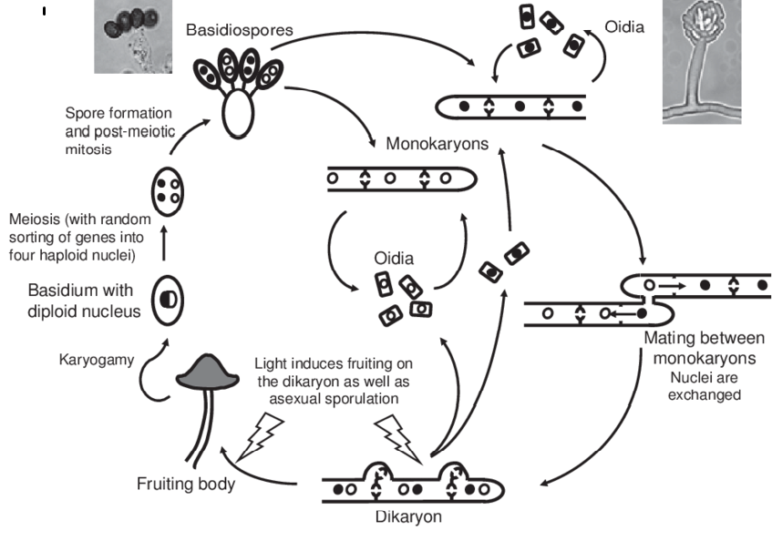

**Step-3: Idea Prioritization**

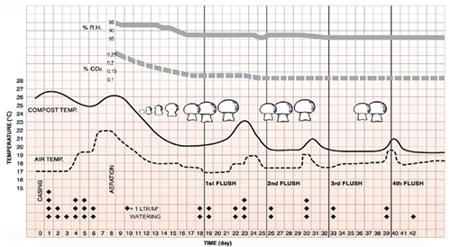

Chart summarizing the evolution of the pivotal parameters for an entire mushroom growing cycle. The black line represents the optimal compost temperature throughout the whole growth cycle. The dashed line represents the ambient air temperature that follows in parallel the compost temperature line. The black dots indicate the amount of water, with each dot corresponding to dm3 m–2, required for an optimal final yield. It also indicates the exact days when the watering should be carried out. Finally, The two grey lines illustrate the optimal values of relative humidity (continuous line) and CO2